**SQL SERVER QURIES:**

**QURIES:**

create database insta

use insta

create table signin

(

usr_id int primary key identity(1,1),

ur_name nvarchar(50) not null,

Phone bigint not null,

Email nvarchar(50) not null,

myPassword nvarchar(50) not null,

)

drop table signin

select * from signin

**OUTPUT:** 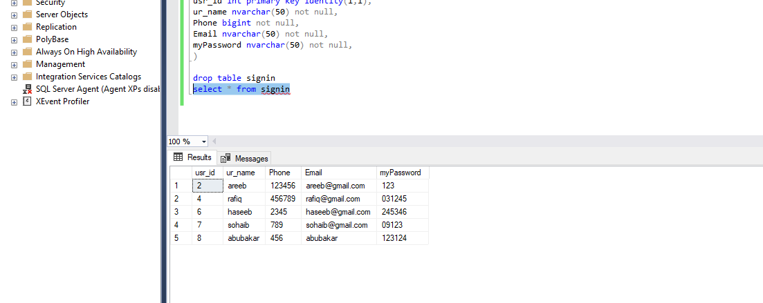

**VISUAL STUDIO:**

**CODE: FORM 1:**

using System;

using System.Collections.Generic;

using System.ComponentModel;

using System.Data;

using System.Drawing;

using System.Linq;

using System.Text;

using System.Threading.Tasks;

using System.Windows.Forms;

using System.Data.SqlClient;

namespace WindowsFormsApp1

{

public partial class Form1 : Form

{

public Form1()

{

InitializeComponent();

}

SqlConnection connect = new SqlConnection("Data Source=DESKTOP-S1PKC0F;Initial Catalog=insta;Integrated Security=True");

int id = 0;

private void Label2_Click(object sender, EventArgs e)

{

}

private void TextBox1_TextChanged(object sender, EventArgs e)

{

}

private void TextBox4_TextChanged(object sender, EventArgs e)

{

}

private void TextBox2_TextChanged(object sender, EventArgs e)

{

}

private void Button1_Click(object sender, EventArgs e)

{

if(textBox1.Text != "" && textBox2.Text != "" && textBox3.Text != "" && textBox4.Text != "")

{

SqlCommand command = new SqlCommand("insert into signin values('"+textBox1.Text+"','"+textBox2.Text+"','"+textBox3.Text+"','"+textBox4.Text+"')",connect);

connect.Open();

command.ExecuteNonQuery();

connect.Close();

MessageBox.Show("Sucessfully signin","Add record",MessageBoxButtons.OK, MessageBoxIcon.Information);

clear();

}

else

{

}

}

public void clear()

{

textBox1.Text = "";

textBox2.Clear();

textBox3.Text = "";

textBox4.Text = "";

}

private void Button2_Click(object sender, EventArgs e)

{

Application.Exit();

}

private void Button3_Click(object sender, EventArgs e)

{

Form2 f2 = new Form2();

f2.Show();

this.Hide();

}

}

}

**OUTPUT FORM 1:**

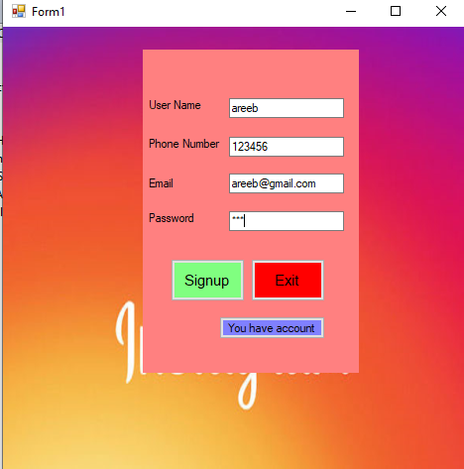

**CODE FORM 2:**

using System;

using System.Collections.Generic;

using System.ComponentModel;

using System.Data;

using System.Drawing;

using System.Linq;

using System.Text;

using System.Threading.Tasks;

using System.Windows.Forms;

using System.Data.SqlClient;

namespace WindowsFormsApp1

{

public partial class Form2 : Form

{

public Form2()

{

InitializeComponent();

}

SqlConnection connect = new SqlConnection("Data Source=DESKTOP-S1PKC0F;Initial Catalog=insta;Integrated Security=True");

private void TextBox2_TextChanged(object sender, EventArgs e)

{

}

private void Button2_Click(object sender, EventArgs e)

{

Form1 f1 = new Form1();

f1.Show();

this.Hide();

}

private void Button1_Click(object sender, EventArgs e)

{

if(textBox1.Text !="" && textBox2.Text !="")

{

SqlDataAdapter adapter = new SqlDataAdapter("select ur_name,myPassword from signin where ur_name = '"+textBox2.Text+"' and myPassword ='"+textBox1.Text+"'", connect);

connect.Open();

DataTable table = new DataTable();

adapter.Fill(table);

if(table.Rows.Count>0)

{

MessageBox.Show("Sucessfully Login","Login",MessageBoxButtons.OK,MessageBoxIcon.Information);

}

else

{

MessageBox.Show("Invalid user name or password","Invalid",MessageBoxButtons.OK,MessageBoxIcon.Information);

}

connect.Close();

}

}

}

**OUTPUT FORM 2:**

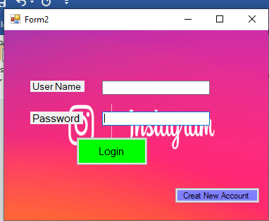

**CONNECTION:**

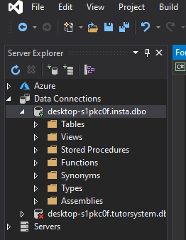

**Run:**

